Implementation of counter using Timer


LAB # 08

Spring 2024
CSE-307L Microprocessor Based System Design Lab

Submitted by: Ali Asghar
Registration No.: 21PWCSE2059
Class Section: C

“On my honor, as student of University of Engineering and Technology, I have neither given nor received unauthorized assistance on this academic work.”

Submitted to:
Dr. Asif Ali Khan

Date:
5th May 2024

Department of Computer Systems Engineering
University of Engineering and Technology, Peshawar

Task 1:
Implement Counter using Timer that take pulses from P3^4

Code:
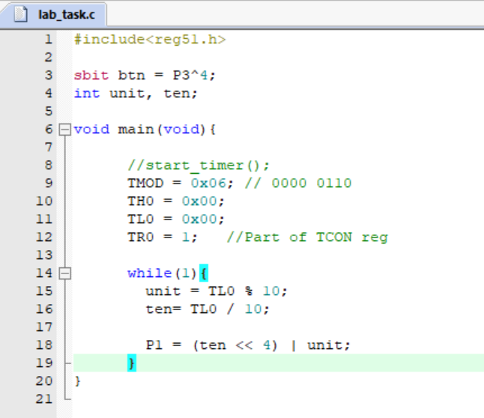

Proteus Simulation:
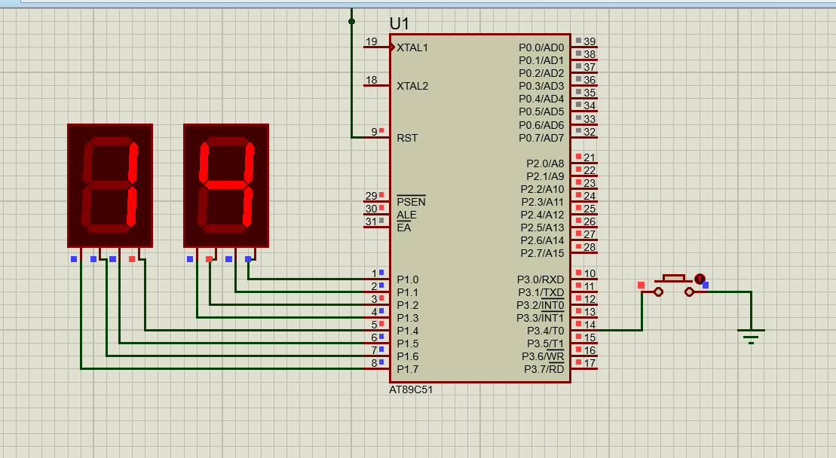
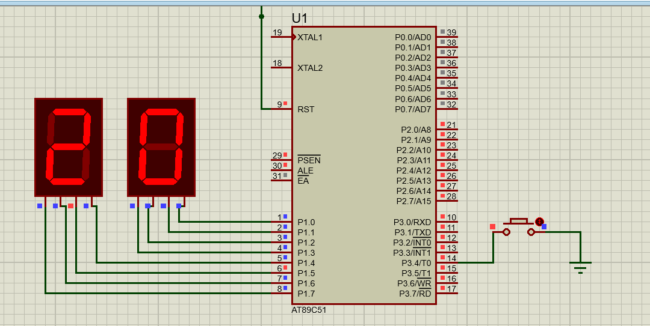

Task 2:
Implement Counter that counts from 0 to 9.

Code:
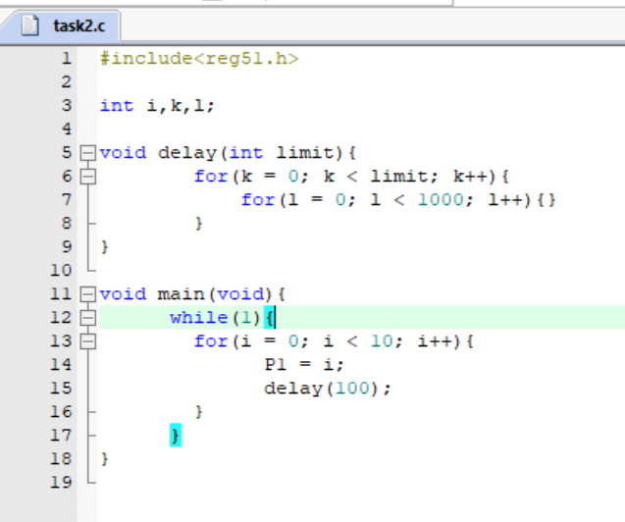
Proteus Simulation:
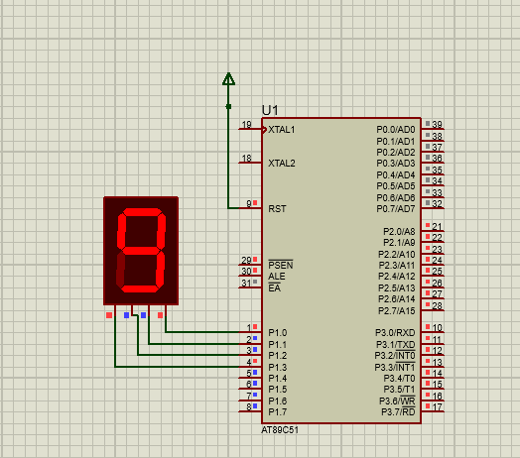
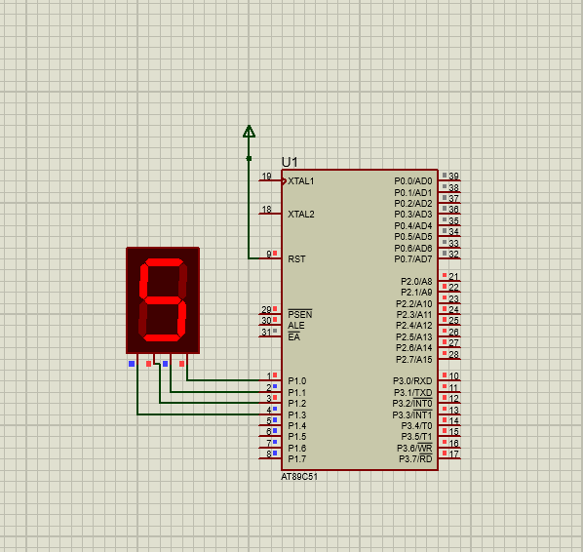

Task 3:
Implement Counter that counts from 00 to 99

Code:
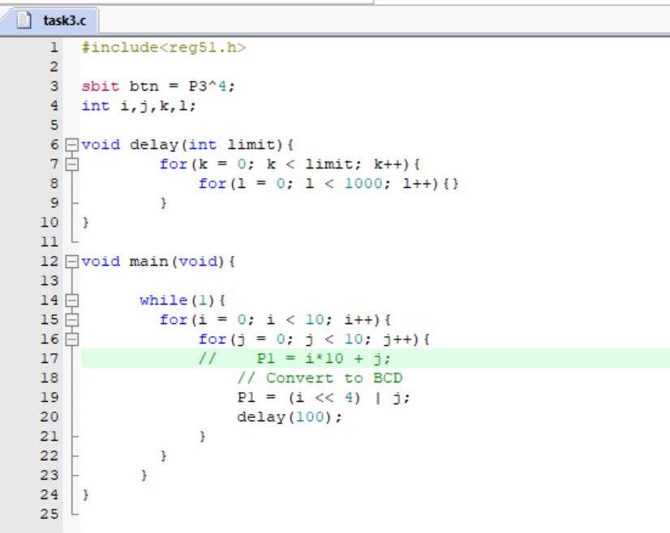
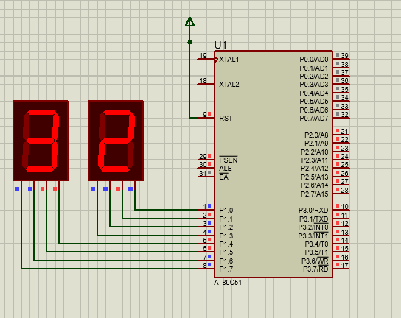
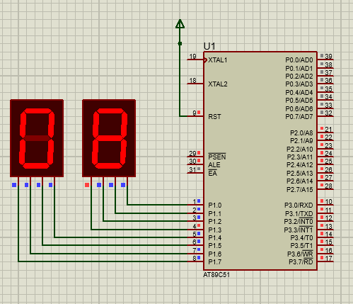
Proteus Simulation:

